**M4 D2 – Overview of Machine Learning families**

**Multiplicative Models:**

* Models based on multiplication:
  + 
* Pre-processing rule of thumb:
  + 
  + Normalization is better for numeric values VS scaling the data
* Multiplicative models create curved boundaries unlike trees, trees make sharp line boundaries.
  + Multiplicative models boundaries visualized:
  + 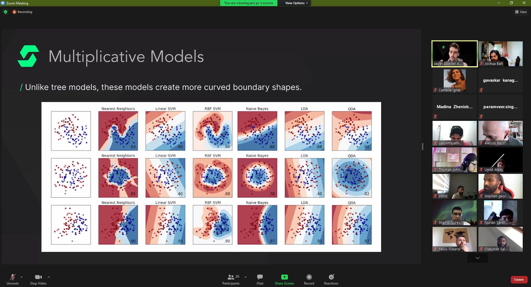
* Scaling just changes the range.
  + 
  + StandardScaler()
    - 
    - Most common scaler
    - Puts median of values in the -1 – 0 – 1 range.
  + MinMaxScaler()
    - 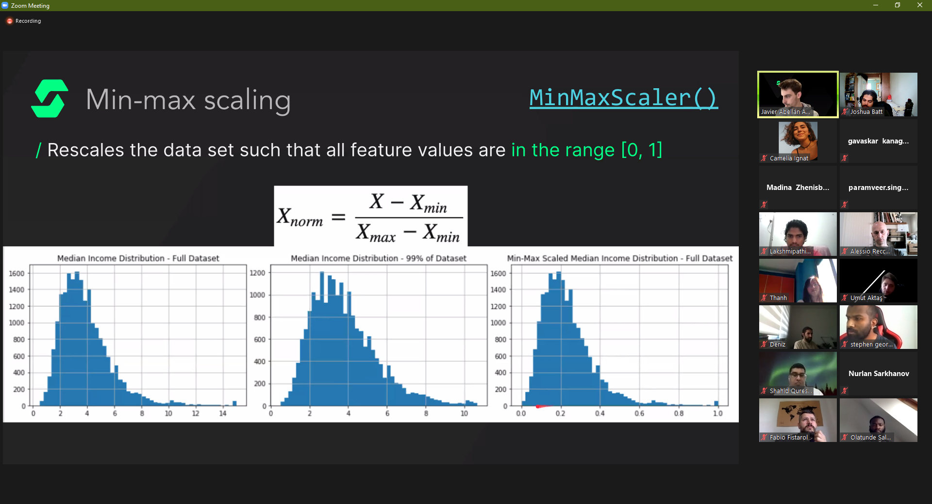
    - Turns the range of values from 0 to 1
    - Not very useful
* Normalization is the other option to deal with numerical values:
  + **Normalization changes the distribution to a normal distribution (bell curve)**.
    - 
    - 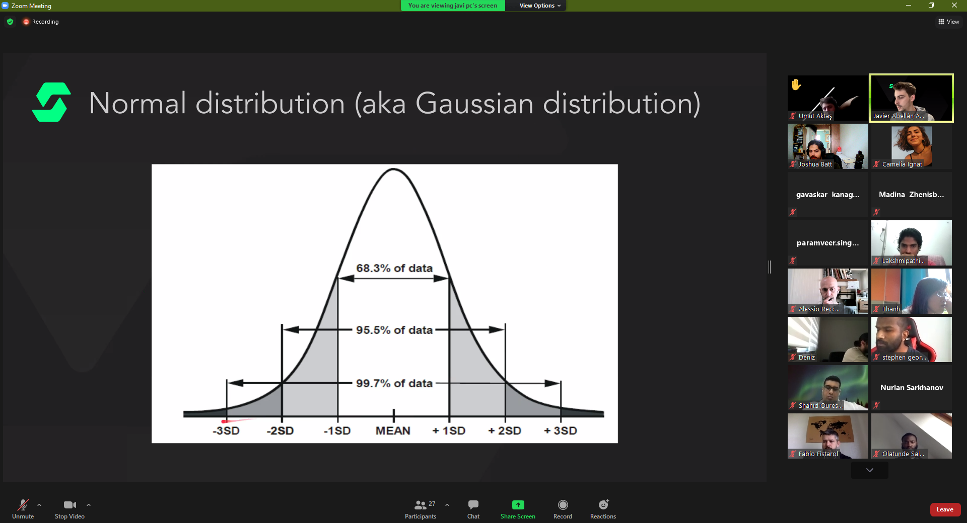
  + Normalization is highly recommended as the method to use.
    - WHY??
  + Skewness, shows us how normal our distribution is:
    - 
  + Kurtosis, how arched the normalization graph is (if its tall or very low and flat)
    - [SCREENSHOT]
  + Methods of applying normalization (manually are done using NumPy):
    - 
      * The 2 functions are powerful.